Case 14-AM,C- Costa Rica-Nicoya-Figure-Male-800 - 1200 CE
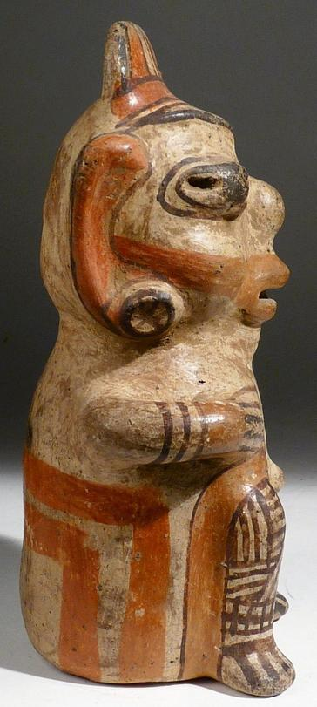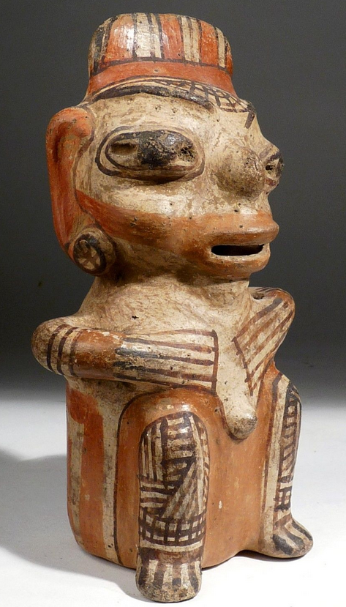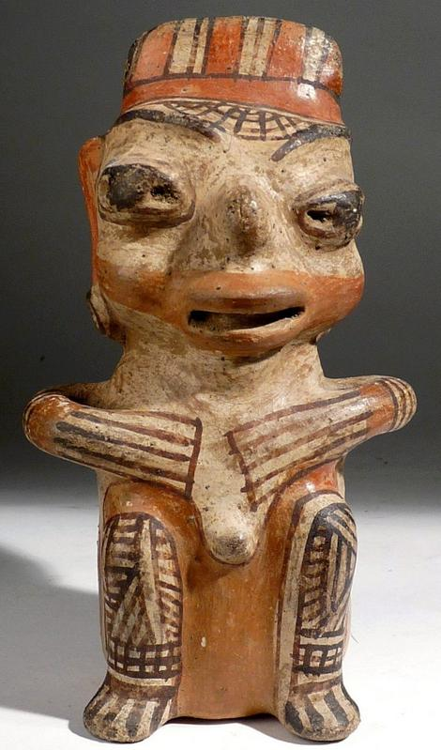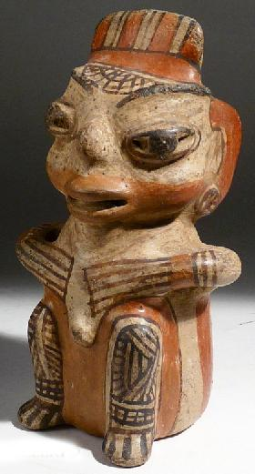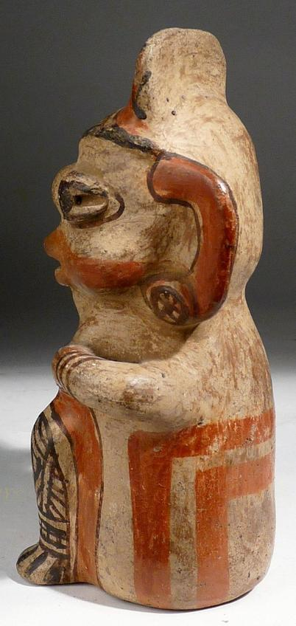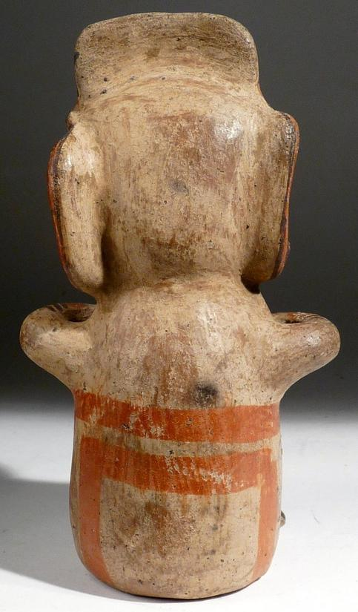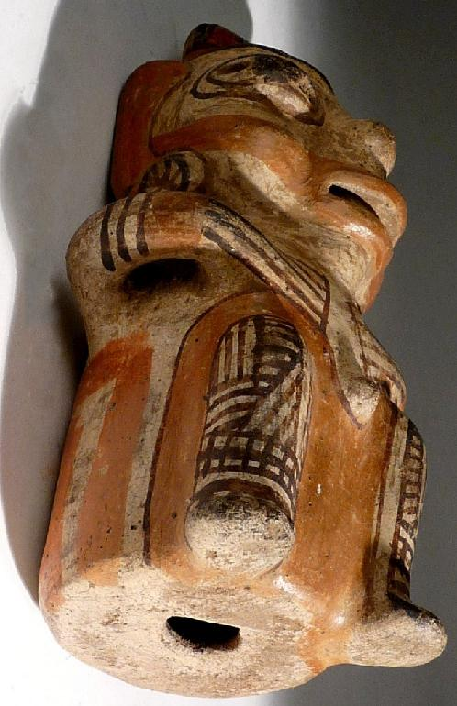
Figs. 1-7. AM,C- Costa Rica-Nicoya-Figure-Male-800 - 1200 CE
Case No.: 14
Accession Number:
Formal Label:
Display Description:
Seated male figure with hands to his chest; tiara headdress; polychrome details painted in vibrant colors with orange and attractive dark umber line work on a white cream colored slip over a brown terra cotta ceramic.
Human habitation of the Greater Nicoya region of southwestern Nicaragua and northwestern Costa Rica extends back in time to the Paleo-Indian period (about 10,000 B.C.), as evidenced by a fluted spearpoint (Snarskis 1981a, 25). Settled human life, probably coinciding with the beginnings of agriculture, began by around 1000 B.C. By 500 B.C. the region's inhabitants had initiated what was to become a 2,000-year tradition of producing artistically excellent ceramics. While plain, utilitarian pottery was always made for food cooking and storage, clay was also used extensively as an expressive artistic medium. Vessels, figures, and musical instruments were manufactured (generally using the coiling method), then decorated with modeling, carving, punctation (repeated indentations), and slip painting.
Firing was usually accomplished by placing the fully dry wares in a slight depression on the ground, then piling fuel over and around them. The relatively low firing temperatures achieved with this method produced earthenware, which is somewhat soft and porous. In some styles, additional decoration (such as incision, scorching, or smoking) was applied after firing. Some of the earliest ceramics (such as Rosales Zoned Engraved) are highly sophisticated, combining sculptural forms with surfaces decorated with carved or incised outlines filled with contrasting slip colors. Throughout the centuries, ceramicists in the region fully explored clay's decorative possibilities, producing solid-colored jars or vessels in the shape of animals or humans (effigy vessels) adorned with linear designs or texturing; spectacular, profusely modeled incense burners with cut-out openings; and beautifully painted polychrome (multicolored) bowls, jars, and figures with smoothly polished surfaces.
From about A.D. 1 to 500, high-status grave offerings in the Greater Nicoya region incorporate finely crafted grave goods, including decorative ceramics like this one as an accompaniment to the deceased.
LC Classification:
Date or Time Horizon:
Geographical Area:
Map:
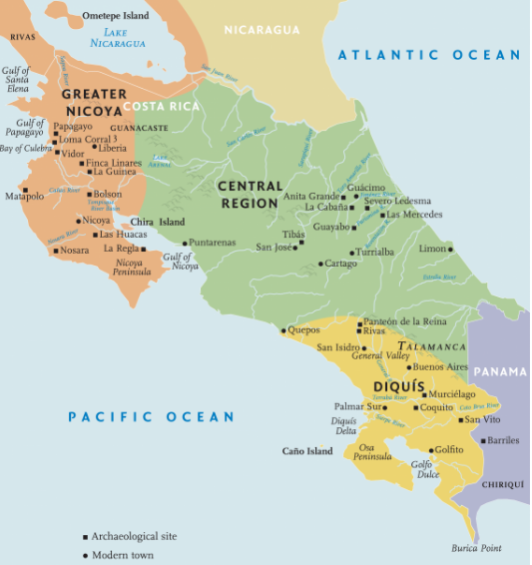
The Nicoya culture area in ancient Costa Rica after https://denverartmuseum.org/article/ancient-costa-rica
GPS Coordinates:
Cultural Affiliation:
Medium:
Dimensions: Height: 7-1/8 in. (18cm).
Weight:
Provenance: Ex Zeus Gallery, C.O.A.
Condition: Intact no repairs. Excellent condition.
Discussion:
References:

Appendix:
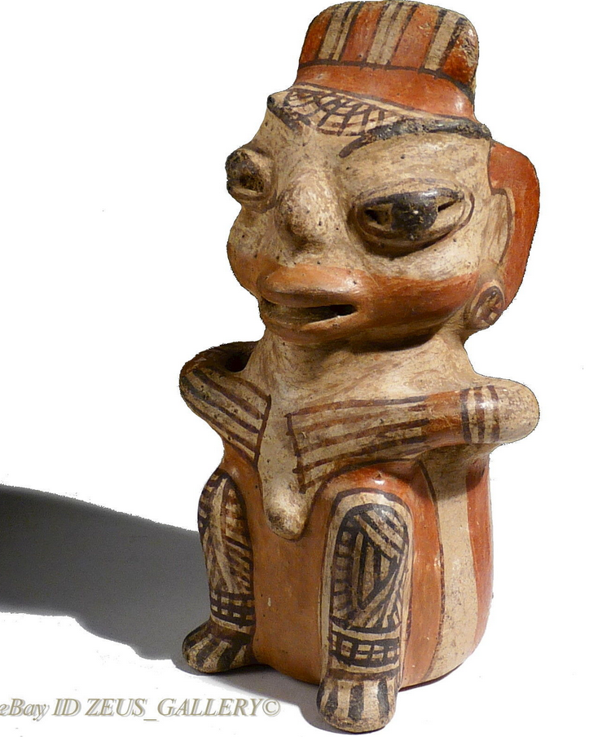
All illustrations are of the actual item offered. The authenticity of all pieces is fully guaranteed. Lifetime Guarantee of Authenticity--Any item ever shown otherwise may be returned unaltered for full refund less shipping. Also, if item purchased is not to your satisfaction you may return it unaltered within 30 days of purchase for a full refund less shipping. We also guarantee absolute discretion and confidentiality in all transactions.

